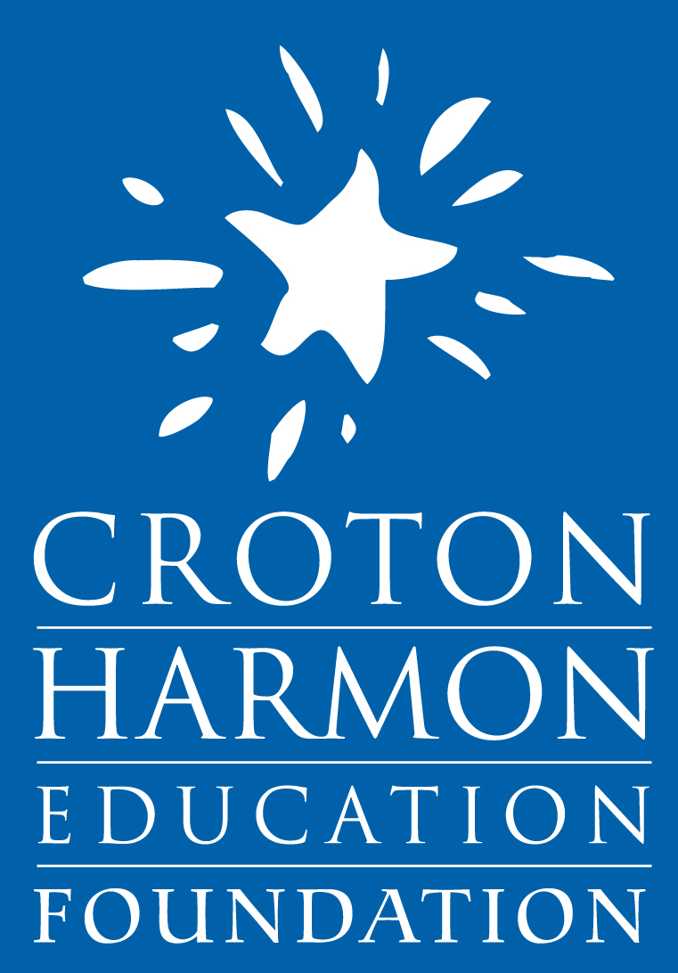
Croton-Harmon Education Foundation

Board Application

Thank you for your interest in joining the Board of the Croton-Harmon Education Foundation (CHEF). Please fill out the information below to help us evaluate your candidacy. Feel free to attach extra pages, if necessary.

For the 2019-2020 board membership term, please submit by May 4, 2018.
Name:
Address:
Phone Number:
Email Address:
- Professional Experience:
(please attach resume if available)

- What skills / perspective / resources do you think you could bring to the CHEF Board?

- How much time per month could you commit to CHEF?
(Note: The Board usually meets once a month during the school year, and Foundation committees may meet once every month or two as well. All Board members are expected to attend most Board meetings and serve on at least one committee.)

- Please describe any previous volunteer / community / nonprofit activities: (please include any prior work with CHEF):

- Why do you want to join CHEF?

- Please indicated which CHEF committees you would be interested in joining:

___ Public Relations/Communications
___ Fundraising
___ Allocation of Grants
___ Technology
___ Finance

Do you have any other comments you wish to make?

Completed CHEF board applications should sent via email to:

vicepresident@crotonfoundation.org

For more information about CHEF, please visit: www.crotonfoundation.org

Thank You!
The CHEF Nominating Committee

